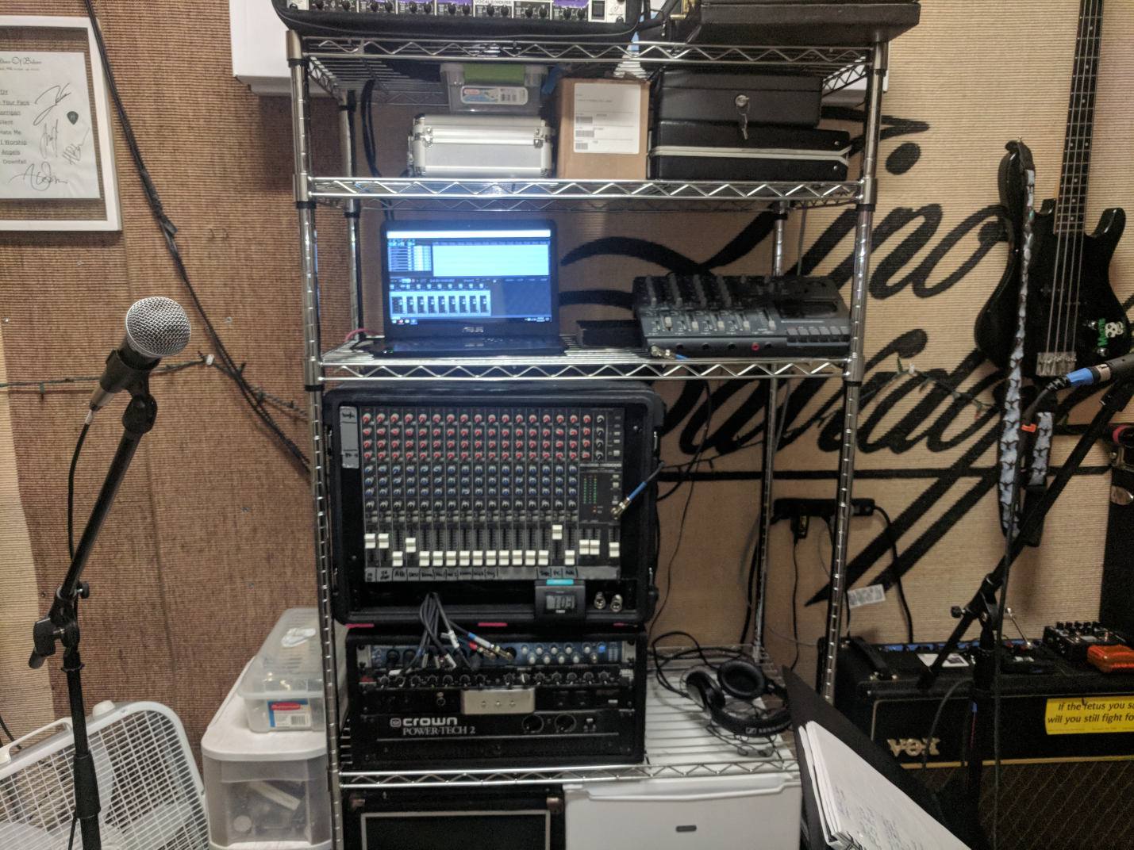

Kloud

**Studio / Audio Reference Guide**

**Version 1.0**

**Danimae Janssen**

**12/15/2017**

# Audio Hardware

## Presonus Audiobox 1818VSL

The 1818VSL has 8 front inputs (denoted by region A in Figure 1), which can be used to record any combination of band instruments/microphones. Each channel is numbered, and has a corresponding input gain adjustment to the right of the inputs (also numbered, in region B). To the right of the input gains, the main out knob controls the level output to the main PA mixer. Adjust if clipping occurs. The headphone output may be used as an easy way to listen to playback from Reaper on the connected PC, if headphones are needed (Note that the mixer itself has a headphone out, which may be preferable since there is zero latency.

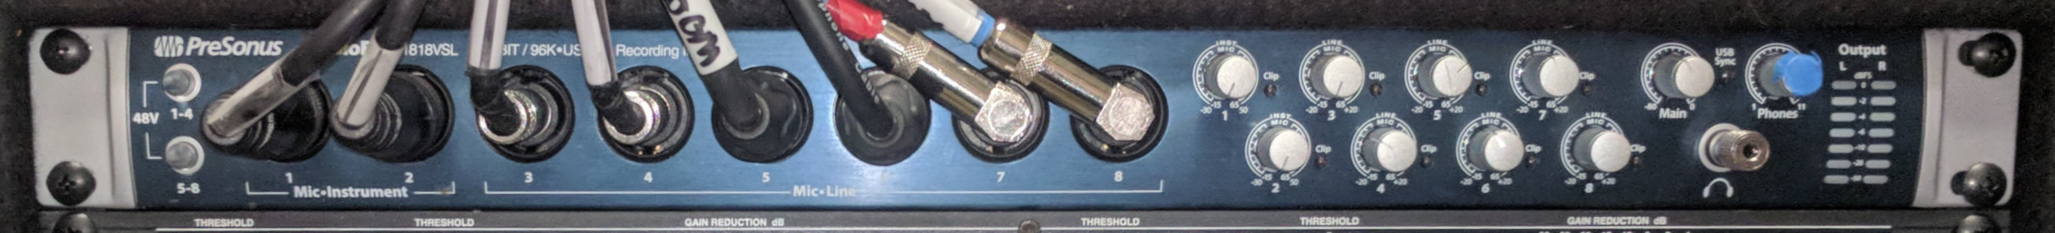

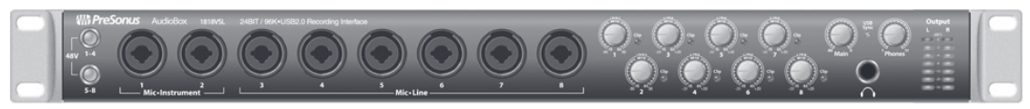

**B**

**A**

Figure 1. Presonus 1818VSL Interface

The input configuration for the VSL is shown in Table 1. Additionally, the XLR cables for snare and kick drum mics can be used in place of the backup vocal and room mix when those mics are needed. The Reaper project is configured according to the above layout, so that the live mix can be recorded at the click of a button.

Table 1. Inputs for the Audiobox 1818VSL

|  |  |  |
| --- | --- | --- |
| Channel | Input source | Description |
| 1 | OH Red | Red banded overhead drum mic |
| 2 | OH Grn | Green banded overhead drum mic |
| 3 | AFX | Axe FX XLR output (cab simulated) |
| 4 | Bass | Ampeg head DI output |
| 5 | Room | SM57 hanging above door |
| 6 | Voc 1 | Kaylee’s mic |
| 7 | Voc 2 | Combined Danimae + Kirsten mics |
| 8 | Total Mix | Output from the Mackie mixer (monitor mix) |

## Mackie CR1604 Mixer

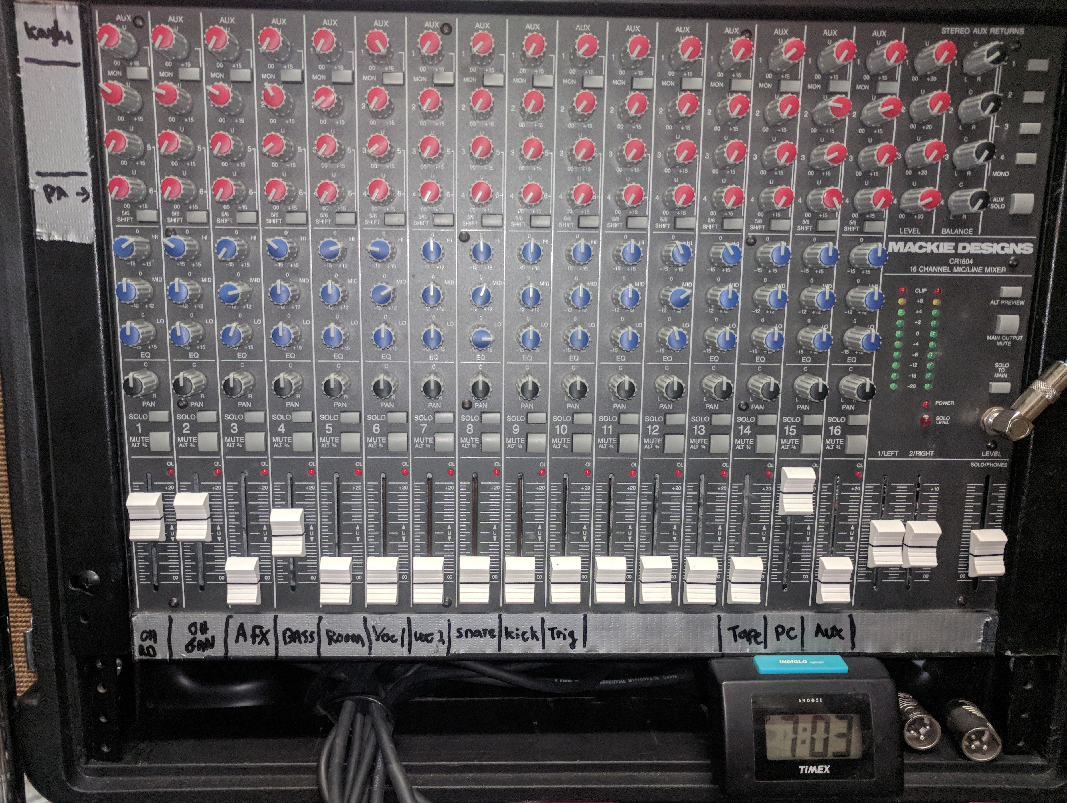

1

2

3

4

**A**

**B**

**C**

**#1 – Secondary IEM (Kaylee)**

**#4 - Output to PA power amp**

Figure 2. Diagram of Mackie CR1604 mixer

### General information

The main mixer takes all inputs from the room, and sends a subset of those channels out to be recorded. In this way, it is possible to monitor the room mix via the Mackie (as desired for in ear monitors / IEMs), while simultaneously recording unmixed individual channels as well as the fully mixed and room signals for later use. This setup allows for a variety of post-processing scenarios – from a quick and dirty demo that requires zero post processing to a professionally mixed down version of the same track.

The non-recorded inputs of the mixer include the aux (1/8th inch for phones, etc), 1818VSL main out (denoted “PC”), tape (playback channel for the tape mix), and trigger sample from the kick module. Note that the mixer takes ALL mic inputs, whereas the 1818VSL is limited to just 8. This means that while choices must be made as to which inputs are actually recorded (snare, kick, toms, etc), ***all of the mics are always available***to the sound board for monitoring/IEMs. Thus, there is no need to ever reconfigure the channel layout on the main board (and in fact, this should not be done without careful consideration).

**The Mackie mixer is used only to control the sound in the room.** Only unmodified signals and the total mix are sent to the 1818VSL (i.e., signals completely unchanged by the mixer controls, and the fully mixed down IEM mix). Therefore, adjustments to the mixer channels (volume, routing, EQ, etc) will **NEVER** affect the inputs to the 1818VSL / PC. In other words, tweak those knobs and sliders away! You will never have to worry about readjusting the 1818VSL gains after doing so (just make sure none of the channels are clipping before recording).

### Using the mixer

Once understood, the mixer is straightforward to operate. The mixer is intended to provide the band and other sources with a fully mixed down live signal. The board also provides some useful auxiliary features, such as routing playback from the PC, aux, or tape player straight into the monitor mix! Finally, the mixer can be used to route any portion of the mix to the power amp to be played back via the PA speaker. Each of the above portions of the mixer’s functionality is controlled by a different subset of components on the board. Figure 2 shows three regions wherein the separate functionalities are grouped.

**Section A** is used for controlling the auxiliary sends of the mixer. The section is split into 4 rows. Each row spans the width of all 16 tracks, and has a single knob for each track. The knobs in each row control the level of its respective track number sent out to the output corresponding to that row number. For example, the 3rd knob from the left (channel 3) on row 1 controls the level of channel 3 that gets sent to auxiliary output 1.

The present configuration is illustrated above – only rows 1 and 4 are currently in use. Row 1 knobs determine the mix sent to the secondary monitor output (used by Kaylee) so that the mix can be tailored to her preference. Knobs in row 4 control the mix sent to the PA poweramp, which is then played back via the PA speaker. Most commonly, this row only sends the PC/tape/aux playbacks to the PA speaker for convenience. Other channels (such as vocals)

can be easily sent to the PA as well by adjusting the appropriate knob in row 4. The final output volume of the speaker can be adjusted on the front of the poweramp (channel A). **This row will have no effect if the poweramp is turned off!!**

**Section B** contains all of the EQ controls. These can be used to adjust the frequency balance of any channel via lo/mid/hi 3 band EQ. It is important to note that the **EQ filters are ONLY applied to the main/phone outputs (monitors), and row 1 of the auxiliary outputs**. This is the design spec of the mixer, and there is no way to change it. Therefore, signals sent to the PA speaker will NOT be affected by the EQ settings. Mostly, I use the EQ on the bass guitar – highs are cut completely, and lo/mid are either normal or slightly boosted. This helps keep the natural treble noise from the bass from clouding the upper midrange of the guitar, and greatly increases the clarity and instrument separation in the ear monitors. All of the other EQ filters are normally set to neutral (vertical position).

**Section C** outlines the controls affecting the main signal level for each channel. The faders control the level for each channel. Also provided are pan knobs, which are not used in our system (we only mix in mono to better represent a live performance environment), and solo/mute buttons. Please make sure that the channel you are using is unmuted (button sticking out), and that solo is similarly disabled. Finally, each channel strip contains a small red LED near the top labeled “OL”. This LED is normally off, and indicates that the input signal is clipping the preamps of the mixer (post fader level). If this light is illuminated the signal will be distorted and action should be taken to correct the clipping situation. To fix this, turn down the input volume for that channel at the source (amp, phone, etc…), or lower the channel fader volume. Worth repeating here is that these controls (and none of them on the board) will affect the 1818VSL inputs. If they are clipping, you must adjust them on the interface controls instead.

Also in section C are the main and phone outputs of the board. The main outputs are sent (in mono) to the IEM’s and the VSL interface. The main outputs have both left and right channels – please note that they should always be increased and decreased together to maintain output signal level. Above these sliders are LED strips for both channels. These show the L/R output levels, and indicate clipping if orange or red. Best practice is to keep them safely in green, and increase IEM volume in the monitor rack if needed. An important note – if the channels are clipping individually (i.e., the “OL” LED is on), the main out levels may still not indicate clipping!! For the best sound, make sure that none of the channel faders shows clipping, AND make sure that the main outs are not clipping. The phone fader controls the level sent to the headphone jack on the front of the mixer, and nothing else. Presently, this output is used as a source for the tape recorder input so that a constant level can be maintained even when the main faders are moved.

**A last note on Section C – the controls in this section will have no effect on the signals being sent to auxiliary channels 1-4. You are free to adjust channel faders and main output levels at will without considering those outputs!!**

Table 2. Channel layout for Mackie CR1604

|  |  |  |
| --- | --- | --- |
| Channel | Input source | Description |
| 1 | OH Red | Red banded overhead drum mic |
| 2 | OH Grn | Green banded overhead drum mic |
| 3 | AFX | Axe FX XLR output (cab simulated) |
| 4 | Bass | Ampeg head DI output |
| 5 | Room | SM57 hanging above door |
| 6 | Voc 1 | Kaylee’s mic |
| 7 | Voc 2 | Combined Danimae + Kirsten mics |
| 8 | Snare | SM57 on snare (when used) |
| 9 | Kick | Audix F12 on kick (when used) |
| 10 | Trig | Trigger sample from TM-2 module on kick |
| 11 | <blank> | Not used |
| 12 | <blank> | Not used |
| 13 | <blank> | Not used |
| 14 | Tape | Input from main out fader of tape recorder |
| 15 | PC | Input from PC via 1818VSL main out knob |
| 16 | Aux | Input from aux source (phone, etc…) |

### Primary mixer channel layout

The channels are labeled as per Figure 2. All but 3 of the channels are presently in used. Refer to Table 2 for the precise descriptions of each channel.

## Tascam tape recorder

The Tascam offers a quick and easy way to record rough demo tracks via a fully analog signal path. Although the recorder offers advanced functions such as quad tracking and buss management via bouncing (thereby allowing more than 4 inputs), the current studio configuration utilizes a very simple approach. This approach prioritizes ease of use and fast tracking to help make an otherwise outdated medium into a realistic and modern throwback. After all, what punk band doesn’t record tapes???

### Using the Tascam

The Tascam is very simple to operate - since the main Mackie board is used to build a real time channel based monitor mix, we can bypass any tape deck mixing operations and simply record the primary board mix! To do so, the headphone output from the front of the main mixer is sent directly to input 1 on the Tascam. The headphone out signal will be identical to the main mix as heard via IEM/line (Kirsten and Danimaes’ mix), but the level is conveniently fixed even if the main L/R output levels change.

Figure 3 shows the Tascam layout. The mix input is routed to channel 1. In order to record the mix, switch A should be set to 1, and switch B to MIC/LINE. When recording, the master fader (C) should be set to zero to prevent a feedback loop! After that, simply adjust the level of fader D until the input LED strip shows signal but no clipping. Ideally, keep this below -5 dB. To record the mix, just push the record button!

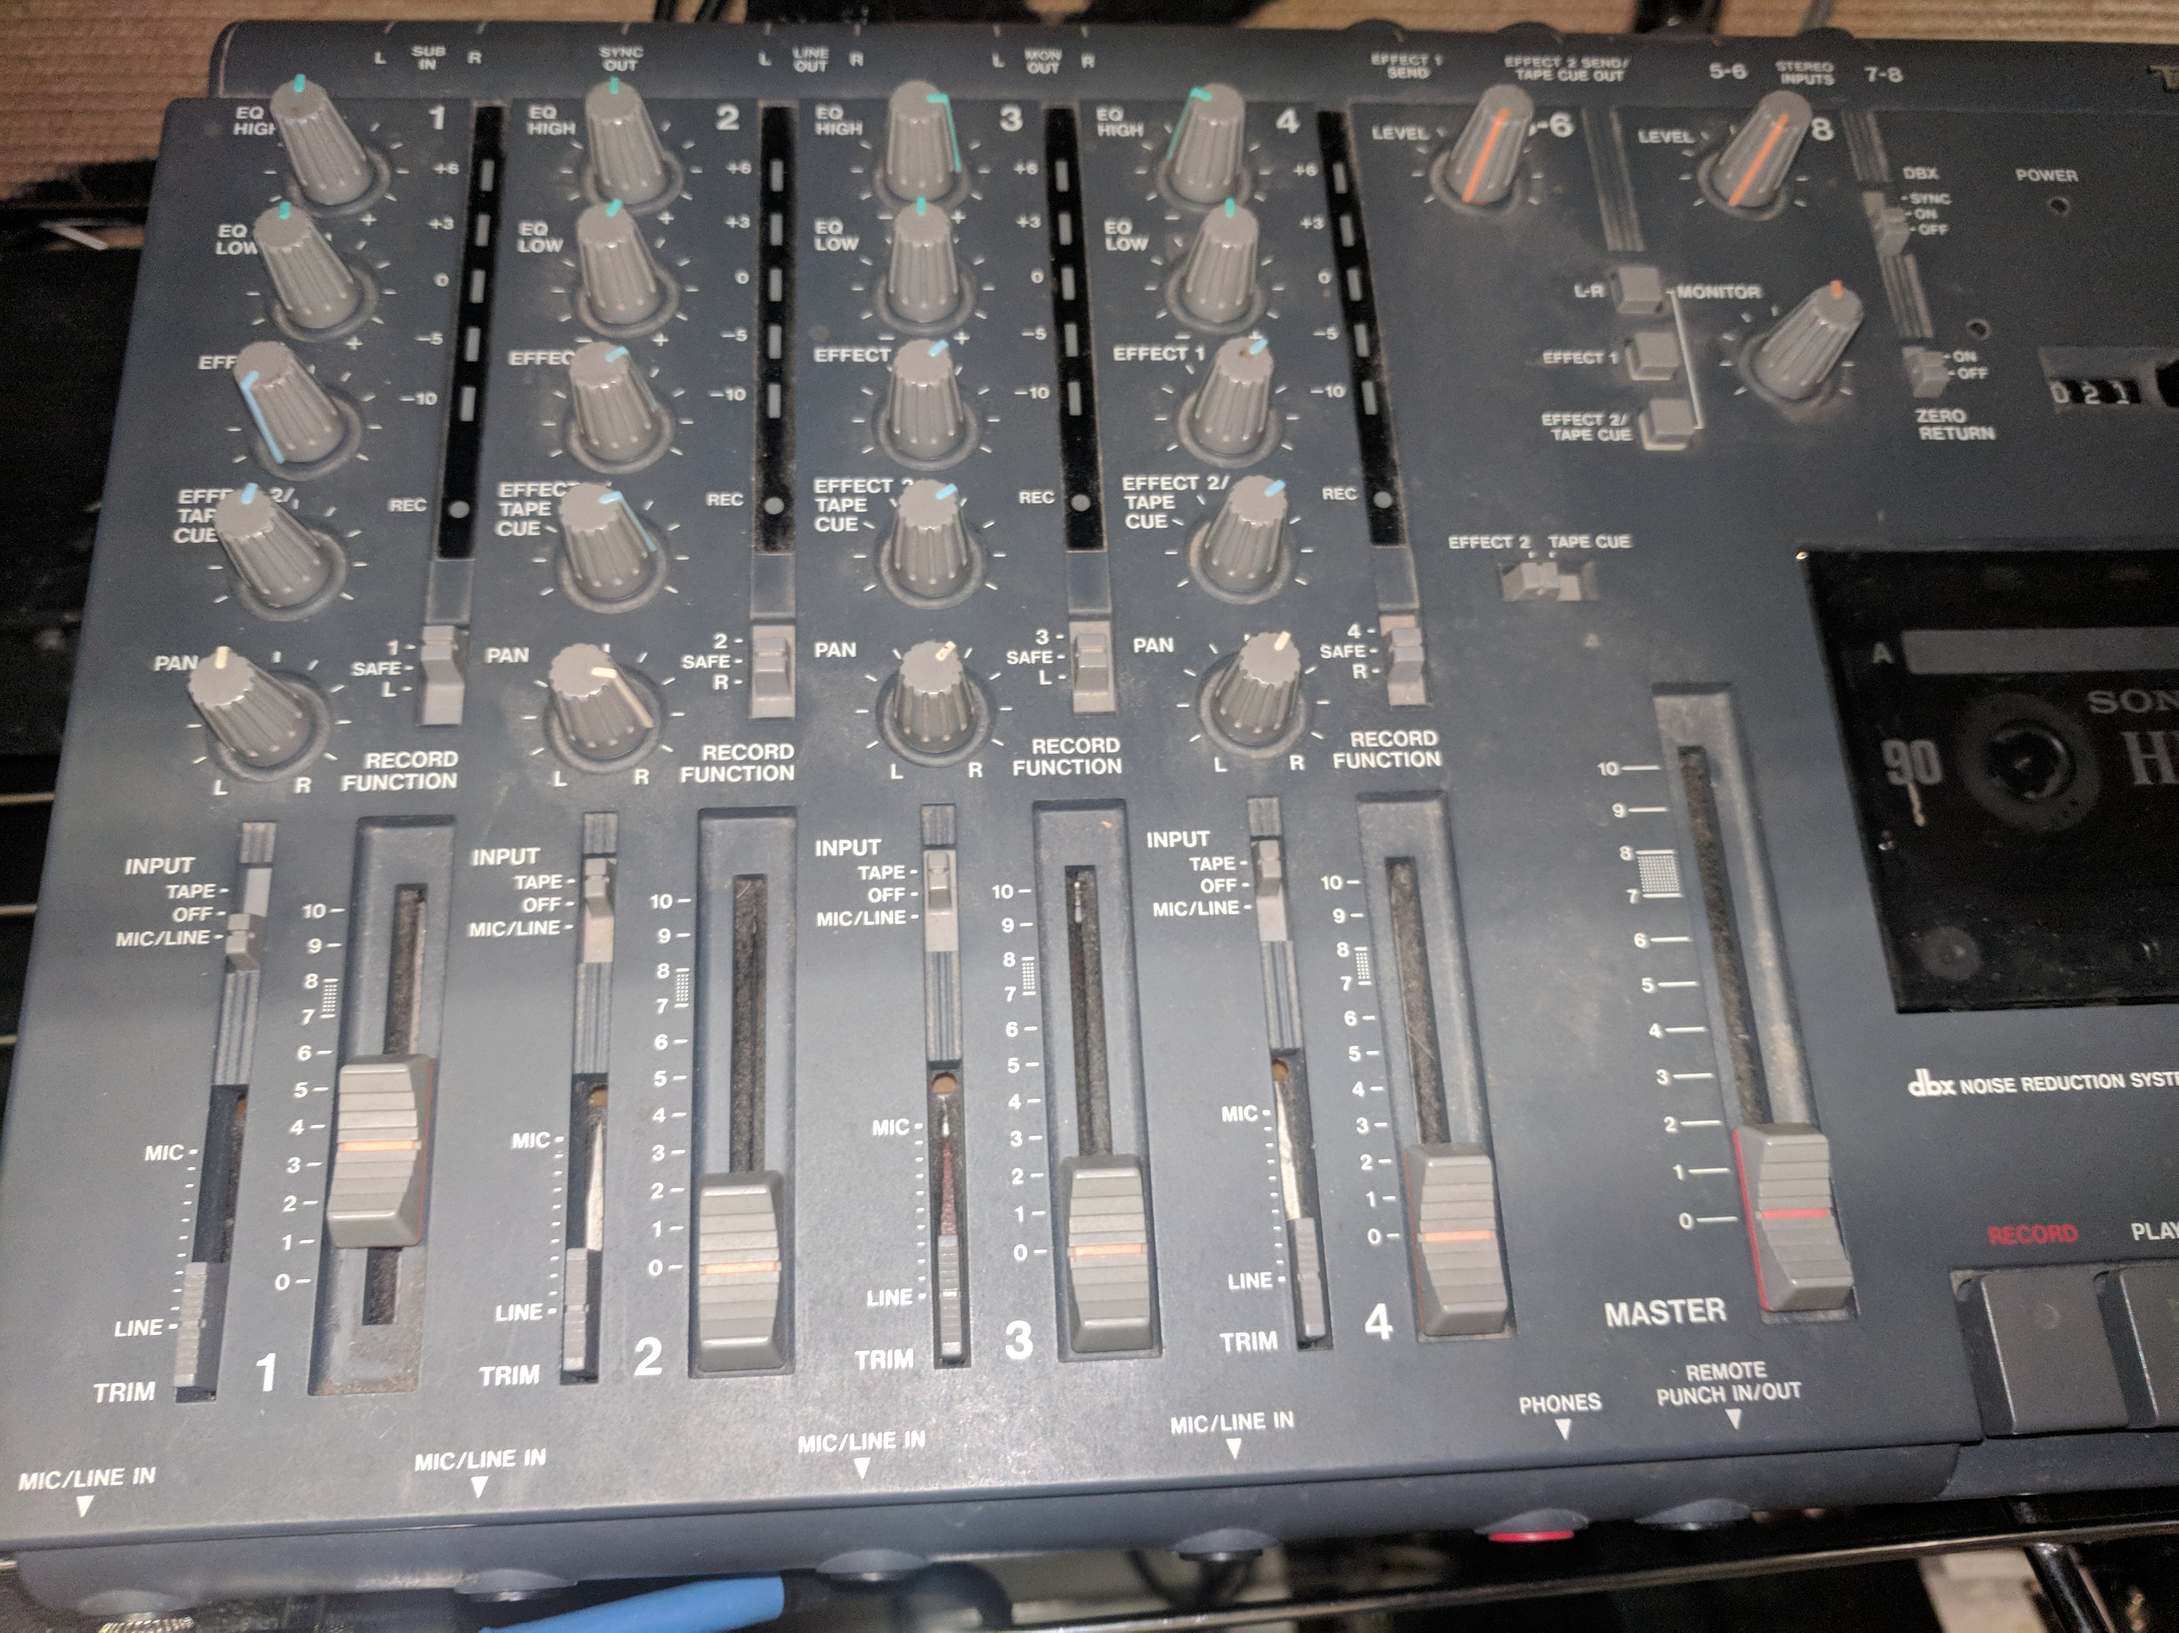

**D**

**A**

**C**

**B**

Figure 3. Tascam recorder diagram

For playback, set switch A to SAFE, and switch B to TAPE. Rewind the tape and push play. Raise fader D until the LED strip shows activity, and then increase the output level (fader C) until the main Mackie board shows signal on channel 14. From this point, you should be able to hear the playback in the main IEM’s or by sending channel 14 to the PA speaker!

## Behringer UltraLink Pro

The UltraLink is responsible for sending the main mix output from the Mackie primary mixer to various monitoring sources. While ultimately unnecessary in our studio, this line mixer is crucial for performances at venues where the input signal level cannot be controlled. It also affords the possibility of doing our own sound onstage where the house mix is not available or incomplete.

In the studio, the UltraLink serves as the final preamp and the last stage before the mix is split and sent off to IEMs. The UltraLink takes a single ¼” input from the Mackie, and splits it. The signal is routed to the Audio Technica M2 for Danimae, and to Kirsten’s board via a direct XLR out. The mix for Kaylee comes direct from the Mackie in the studio (auxiliary channel 1) and is not run through to UltraLink, since her mix is different from the main mix. On stage, all IEM signals come through the UltraLink.

### Using the UltraLink

From an operational standpoint, the unit is extremely simple. It serves as either a splitter or a mixer. In our case, it is used as a mixer and should therefore be configured appropriately. In Mix mode, channels that are active must have the rectangular buttons in “MIX” position. The buttons will be illuminated green in this case – only the channels in use need to be activated. Also, **please make sure the unit is powered on, or no monitors will have sound!!!**

**A**

**B**



**Output signal**

**Input signal**

Figure 4. Behringer UltraLink Pro

There are two regions on the UltraLink, denoted A and B in Figure 4. Region B contains 6 input channels, each of which has its own level/pan controls. In our case, we use a simple mono mix, so the pan knobs should always be set to zero. The input signal can be monitored with the LED strip above the channel (shown in Figure 4). In our setup, the mix is always routed to channel 4. Adjust the gain gain/level knob for channel 4 until the input signal is safely below 0 dB. If the signal is in the orange region, unpleasant clipping will occur!!

Assuming that the input gain is not clipping, the final output to the in-ear monitors can be adjusted by using the knob on the right in region A. The small meter above this knob shows the output lever – once again, it is recommended to adjust this such that the level is safely below 0 dB. The knob on the left can be ignored, since it only applies to the splitter mode of the UltraLink. A final note – if the input signal cannot be adequately controlled using the gain knob, you can adjust the primary output of the Mackie mixer as well. If you hear clipping but the meters on the UltraLink are green, then check the Mackie for clipping.

# Quick Use Sheets

## Setting up

Power on all equipment via the switch on the power conditioner in the same rack as the Presonus 1818VSL. The Behringer mixer and wireless monitor units must be turned on manually. The Tascam has a hidden power switch on the back near where the cord plugs in.

## Using the system for monitoring

Table 3. Input layout for the Mackie CR1604 Mixer

|  |  |  |
| --- | --- | --- |
| Channel | Input source | Description |
| 1 | OH Red | Red banded overhead drum mic |
| 2 | OH Grn | Green banded overhead drum mic |
| 3 | AFX | Axe FX XLR output (cab simulated) |
| 4 | Bass | Ampeg head DI output |
| 5 | Room | SM57 hanging above door |
| 6 | Voc 1 | Kaylee’s mic |
| 7 | Voc 2 | Combined Danimae + Kirsten mics |
| 8 | Snare | SM57 on snare (when used) |
| 9 | Kick | Audix F12 on kick (when used) |
| 10 | Trig | Trigger sample from TM-2 module on kick |
| 11 | <blank> | Not used |
| 12 | <blank> | Not used |
| 13 | <blank> | Not used |
| 14 | Tape | Input from main out fader of tape recorder |
| 15 | PC | Input from PC via 1818VSL main out knob |
| 16 | Aux | Input from aux source (phone, etc…) |

Connect all instruments and devices such as PC, aux, tape, etc and begin playback

Check each instrument for levels. Watch the appropriate channels on the Mackie (refer to Table 3). Make sure the “OL” LED does not illuminate and that the channel meter does not show clipping.

Listen and mix all levels to taste with the main faders, using EQ if necessary. Adjust the main output level so that no clipping occurs.

Adjust auxiliary outputs (rows 1 – 4 on the top region of the Mackie) to send audio to the second wireless unit (row 1) and the PA system (row 4) as desired.

If using the PA speaker, turn on the power amp and adjust the volume of channel 1 as needed.

Adjust the input gain on the Behringer UltraLink to avoid clipping.

Adjust the output gain on the Behringer UltraLink to avoid clipping.

Finally, adjust the volume level of your personal device (wireless pack or mixer) to suit your needs. Do not increase volume on the racks unless your device is not sufficient (helps avoid accidentally pushing a very hot signal).

Jam away!!

## Using the system for recording

Table 4. Inputs for the Audiobox 1818VSL

|  |  |  |
| --- | --- | --- |
| Channel | Input source | Description |
| 1 | OH Red | Red banded overhead drum mic |
| 2 | OH Grn | Green banded overhead drum mic |
| 3 | AFX | Axe FX XLR output (cab simulated) |
| 4 | Bass | Ampeg head DI output |
| 5 | Room | SM57 hanging above door |
| 6 | Voc 1 | Kaylee’s mic |
| 7 | Voc 2 | Combined Danimae + Kirsten mics |
| 8 | Total Mix | Output from the Mackie mixer (monitor mix) |

Power up and check levels as normal for monitoring

Open the band Reaper project on the PC.

Arm each track for recording.

For each input, check the levels. If you see clipping in Reaper, adjust the preamp gain control on the front of the 1818VSL as appropriate. If the signal is low in Reaper, make sure to increase the level to a range of -3dB for the loudest sound you expect to produce.

Do not worry about balancing the levels in Reaper – all tracks are independent and can be mixed later.

Once all tracks have been tested for input signal, you are ready to record!

Press the red circle button in Reaper to begin recording. Any tracks you have armed will start recording!

You may want to do a few test runs. When you stop recording and play back the tracks, you will be able to hear the output but increasing the level of channel 15 on the main Mackie mixer. Be sure to dial it into the PA system as described above if you want to hear it played back on the speaker.

Tracks 5 and 8 on the 1818VSL are normally set for recording the room mix and the monitor mix. You can solo one of these tracks in Reaper if you just want to hear a rough mix of everything, or you can solo specific tracks/combinations of tracks to check your work.

Enjoy!